Enhanced CNN Based Deep Learning Model for Tomato Leaf Disease Detection

Thammisetty Swetha1[0009-0003-4747-5716], Pakanati Shiva Kumar Goud2[0009-0007-9018-7583],

Thokala Vishnu Vardhan3[0009-0009-6414-7232], Balam Supriya4[0009-0002-7769-6061],

Bijivemula Sumanth Kumar Reddy5[0009-0003-2396-024X], Chakkera Sai Prasanna6[0009-0003-2984-037X]

1,2,,3,4,5,6 Department of Computer Science & Engineering (Data Science), Madanapalle Institute of Technology & Science, Madanapalle, Andhra Pradesh, India

1[swethathammisetty7@gmail.com](mailto:swethathammisetty7@gmail.com) ,2shivak05p@gmail.com,  
3[vishnuvardhan280403@gmail.com](mailto:vishnuvardhan280403@gmail.com), 4supriyapriya57584@gmail.com,  
5[bijivemulasumanthkumarreddy@gmail.com](mailto:bijivemulasumanthkumarreddy@gmail.com), 6prasannachakkera2004@gmail.com

**Abstract**-Tomatoes (Solanum lycopersicum), which originated in South America, are now widely grown around the world. India is one of the largest producers and consumers of tomatoes. But also, this crop is widely affected by various diseases like bacterial spots, early blight, and late blight, which result in huge loss for cultivators. So early detection and preventive measures can have a good result in increasing the yield of tomatoes. In this study, we have proposed CNN (convolutional neural networks). A model involving image preprocessing and data augmentation by taking a dataset that comprises a total of 10000 images belonging to 10 different classes, which resulted in an overall 98.6% train accuracy and 97.78% test accuracy This study will be useful for the early detection of disease, making it user-friendly and cost-efficient for all farmers.

**Keywords:** Solanum lycopersicum, CNN, Accuracy, Precision, Recall.

1. Introduction

In recent years, agriculture had a transformative shift towards precision farming and smart agriculture, leveraging advanced technologies to enhance crop yield and losses. Tomato (Solanum lycopersicum) being a key component in food supply, face challenges numerous challenges posed by various diseases like Bacterial spot, Early blight, Late blight, Leaf mold, Septoria leaf spot, Spider mite, Target spot, Mosaic virus, yellow leaf curl virus. Which impacts its yield and quality. Early detection and prevention of these diseases is crucial for implementing effective crop management. Traditional methods of disease identification in tomato plants often rely on inspection, which is time consuming and susceptible to human error. In the era of digital agriculture, the integration of cutting-edge technologies such as deep learning has emerged as a promising solution to automate and improve accurate disease prediction. This paper focuses on the application of deep learning techniques for the detection of tomato leaf diseases, aiming to provide an efficient tool for farmers. Deep learning is a subset of machine learning that deals with image recognition tasks, making it well-suited for the complex and visually distinctive nature of plant diseases. Our proposed methodology employs on convolutional neural networks (CNNs), a class of deep learning models designed for image analysis, to extract intricate patterns and features from tomato leaf images of a total number of 18,356 images belonging to 9 disease classes and 1 health class .By training the model on a diverse dataset, the model learns and predict the various diseases. The main purpose of this study is to offer disease identification, allowing farmers to implement effective methods, minimize crop losses and identify the disease leaves. Additionally, deep learning models facilitate their integration into existing agricultural technologies, paving the way for real time monitoring and decision making. Coming to dataset we have retrieved it from the Kaggle dataset source and developed a CNN model to classify the images. Fig. 1 Information About Classes in Dataset. The performance of the model has been analyzed for training accuracy and validation accuracy. TABLE 1 shows the parameters used in model, The subsequent paper is as follows Related work, About Dataset, proposed methodology, Experimental analysis followed by conclusion.

1. Related Work

Shengyi zhao [1] et al. used CNN network integrated into SE-ResNet50 model for the diagnosis of tomato leaf disease. Hande Yukel Bayram [2] et al. used six different Convolutional Neural Network (CNN) consists of classification task carried out by predefined models and Neighbourhood Component Analysis (NCA) is applied for feature map extraction, the average accuracy was 99.50%. Naresh K.trivedi [3] et al. used 3000 images and extracted characteristics from pictures like colors, textures, and edges and his proposed model predictions are 98.49% accurate. P Sreelatha [4] et al. used DNN (Deep Learning Neural Networks) and the proposed model accuracy was 86.18%. Keke Zhang [5] et al. used ResNet(stochastic gradient ) with batch size of 16 with a fully connected layer of iterations up to 4992 and accuracy was 97.28%. Yang wu [6] et al. proposed a DCNN (Deep Learning Convolutional Network) an Intelligent Automation. Usama Mokhtar [7] et al. used SVM Machine Learning Algorithm with 100 image samples and accuracy was 99.5%. Princi Rani [8] et al. also performed Disease Detection of Tomato leaves using SVM and acquired accuracy was 95%. Nazam Nahar [9] et al. used predefined models of CNN like MobileNet and DenseNet both were ensembled with 16,035 images and accuracy was 98.21%. Emine Cengil [10] et al. proposed Hybrid convolutional neural network using AlexNet, ResNet50 and VGG16. Ended up with accuracy of training and testing -98.38% and 96.3% respectively. Alvaro Fuentes [11] et al. proposed a CNN model for plant disease recognition in real-field scenarios. Mohit Agarwal [12] et al. proposed CNN with 3 convolutional layers with an accuracy of 91.2%. Juncheng Ma [13] et al. used CART (Classification and Regression Tree Algorithm) and resulted with 90.67% accuracy. Thair A Salih [14] et al. proposed CNN model for Tomato Leaf Disease classification and acquired accuracy of 96.43%. Aliasghar Mortazi and Ulas Bagci [15] et al. designed CNN architectures for medical image segmentation using image segmentation. M Kaushik [16] et al. used predefined CNN model ResNet with data augmentation of images and produced 4 times more than the actual dataset with acquired accuracy of 97%. Yuhua Li Zhihui Luo [17] et al. proposed an Extended collaborative representation (ECR) on cucumber disease. Konstantinos P Ferentinos [18] et al. Proposed CNN model using 58 classes comprised of 87,848 images, with an accuracy of 99.53%. Parul Sharma [19] et al. proposed a self-classification CNN model and F-CNN model with 98.6% accuracy. Muhammad EH Chowdhury [20] et al. proposed a deep learning automatic detection model with EfficientNet -B4 with 99.89% accuracy. Antonio Guerrero-Ibanez [21] et al. proposed CNN model with 99% accuracy. Mchdhar SAM AI-gaashani [22] proposed CNN model which extracts features using pre-trained kernels weights from MobileNetV2, NesNetMobile using Regression with accuracy of 974%. Prajwala Tm [23] et al. used CNN predefined model Lenet and acquired 95%. Natheer Khasawnch [24] et al. proposed CNN model using 9 different classes and acquired 99.4% accuracy. Channamallikarjuna Mattihalli [25] et al. proposed automation detecting plant leaf disease. As per the previous model proposed by keke Zhang [5] overall Training, Testing accuracy was 96.51% and 97.19%.

Also, our proposed model’s performance was 98.6% for training and 97.78% for testing. As of we have reduced the data complexity of the images but while dealing with more image’s integration of Resnet50 and CNN outperforms more while compared to other neural networks.

1. Proposed Methodology

In our study, we started our analysis on tomato leaf disease prediction by collecting dataset form the database of Kaggle [5], where the data is already pre-processed without the need of feature engineering. The dataset contains nearly 41127 images of tomato leaf disease. out of them, 10000 images, 1000 per class are collected for our analysis to increase model efficiency and to reduce model complexity in such a way that the model gives higher performance, where each layer of model is trained . Model description is illustrated in table 1. And Types of leaf classes used is shown in Fig. 1.

**Table 1**. Model parameters description.

|  |  |
| --- | --- |
| Model Parameters | Value |
| Conv_2d | 6 |
| Total Parameters | 184202 |
| Trainable Parameters | 184202 |
| Non-Trainable Params | 0 |
| Optimizer | Adam |
| Metrics | Accuracy |
| Epochs | 25, 50 |
| Batch_size | 32 |

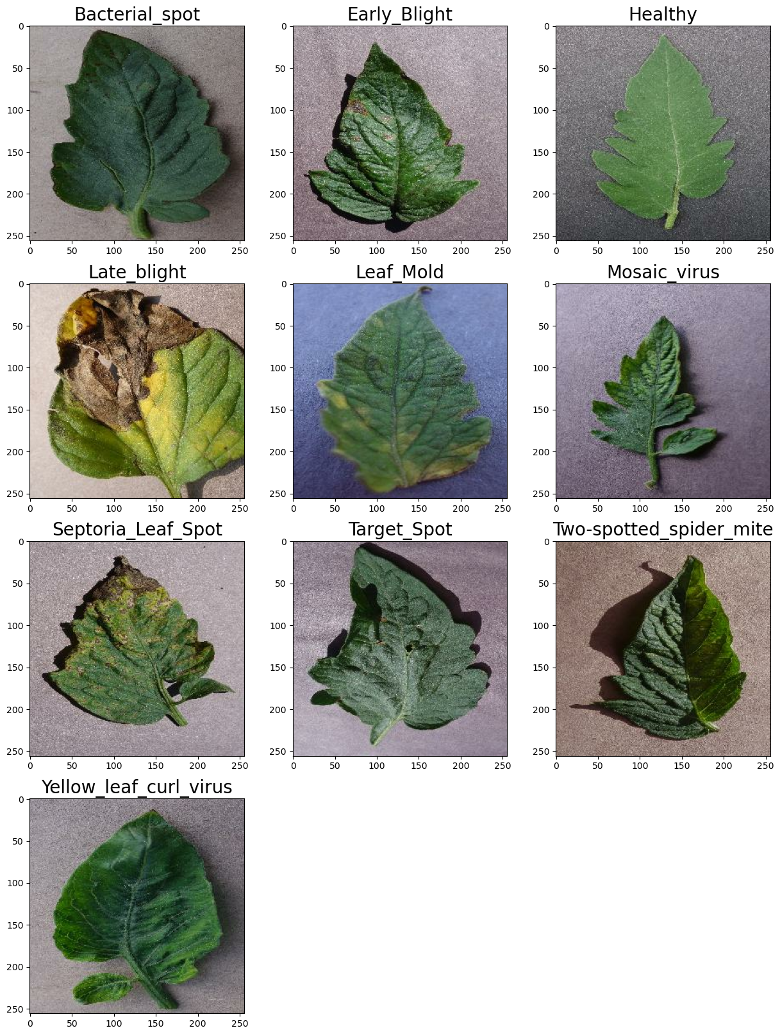

**Fig.** 1. Types of leaf samples taken for experiment.

It is commonly used for preprocessing the input images before feeding them into a neural network, Data Augmentation (Horizontal Flip(20%), Random Zoom (20%), and Rotation(30 degrees), where images are randomly flipped both horizontally and vertically. It creates augmented versions of the original images. Random rotation is Done to

introduce variability in the orientation of the Images. The Zoom factor is sampled uniformly from the range[0.3,0.2].

These Augmentation techniques are commonly Used to enhance the diversity of training data for neural networks and make it more robust and effective at generalizing unseen data. CNN model of Six Convolutional Layers with different filter sizes and activation functions -Each layer extracts features from the input images using convolutional operations – The first layer has 32 filters with a 3x3 kernel, followed by 64 filters in subsequent layers. The activation function used is ReLU (Rectified Linear Unit) Max pooling layers after each convolutional layer to down-sample the feature maps. – The pooling window size is (2,2), Which will reduce the spatial dimensions by half. The flattened layer converts the 2D feature maps into a 1D vector. It will prepare the data for the fully connected layers. With two dense (fully connected layers) the first dense layer has 64 units with the Relu activation function. The second dense layer has ten units with a SoftMax function. The final layer produces class probabilities for ten output classes (classification task).

During model compilation, Adam optimizer was used, which is an adaptive learning rate optimization algorithm. Sparse Categorical Cross entropy is a loss function suitable for multiclass classification tasks where the target labels are integers. The metric used is Accuracy during training, which measures how often the model’s prediction matches the actual labels. Using epochs 25 and 50, the model iterates over the entire training dataset 25 to 50 times. It gives validation accuracy and loss of batch size 32. Subsequently, the evaluation is done on the test dataset to measure the performance of the model. where the Accuracy, Precision, Recall, and F1-score will be calculated using the Actual and Predicted classes. In summary, our comprehensive approach to image classification and detecting diseased leaf images encompasses data pre-processing, data augmentation, feature extraction, model training, and evaluating the model using the test dataset (10%) of the overall dataset. This is the Architecture of the proposed model as shown in Fig. 2.

­­­­­­­­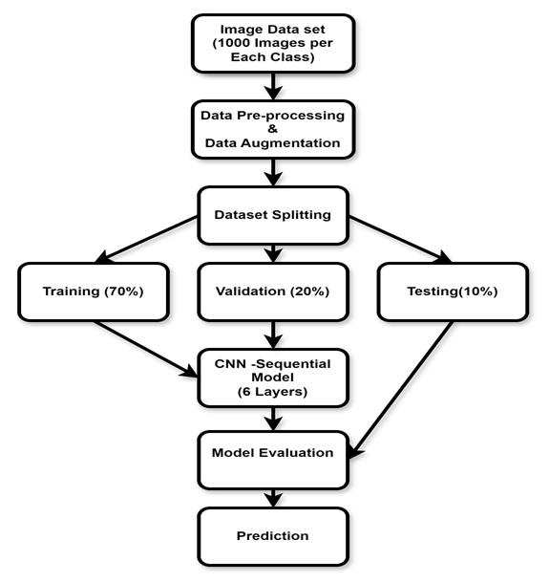

**Fig.** 2. Proposed Methodology.

1. Experimental Analysis

In this segment, we present the results of our research on the classification and detection of tomato leaf disease using CNN (Convolutional Neural Network). The experiment was carried out on an Intel Core i7 system with 32 GB of RAM, using various Machine Learning and Deep Learning libraries in the Jupyter web application environment. Our analysis of this research involved three main phases. Firstly, we collected 10,000 images of 10 different classes and resized them to 256 X 256 pixels each. We then performed data preprocessing to normalize the images and applied Data Augmentation techniques to enhance the diversity of the training data. Moving on to the second phase, we divided the Image Dataset into three sets: 70% for Training, 20% for Validation, and 10% for Testing. We created a CNN sequential model with six convolutional layers followed by max-pooling layers, flattened and made dense with SoftMax function. We used the optimizer adam and epochs 25 and 50 to reduce the loss rate of both training and validation data. as shown in Fig. 3&4 Accuracy of both Training and Validation is 98.08% and 98.96% respectively.

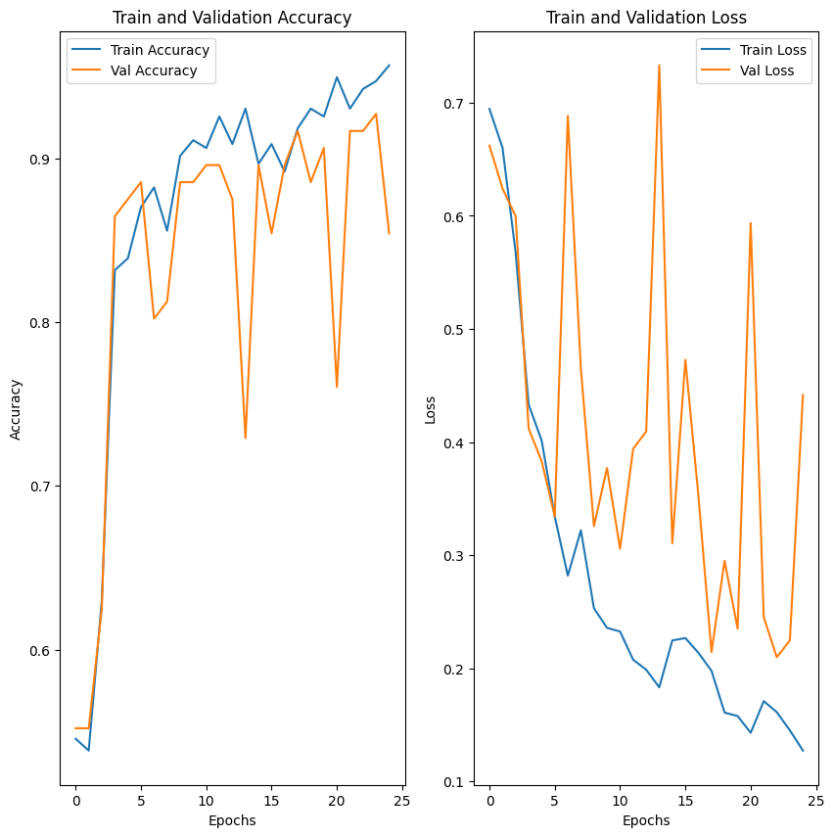

**Fig.** 3. Accuracy v/s Loss (25 Epochs) for Training and Validation.

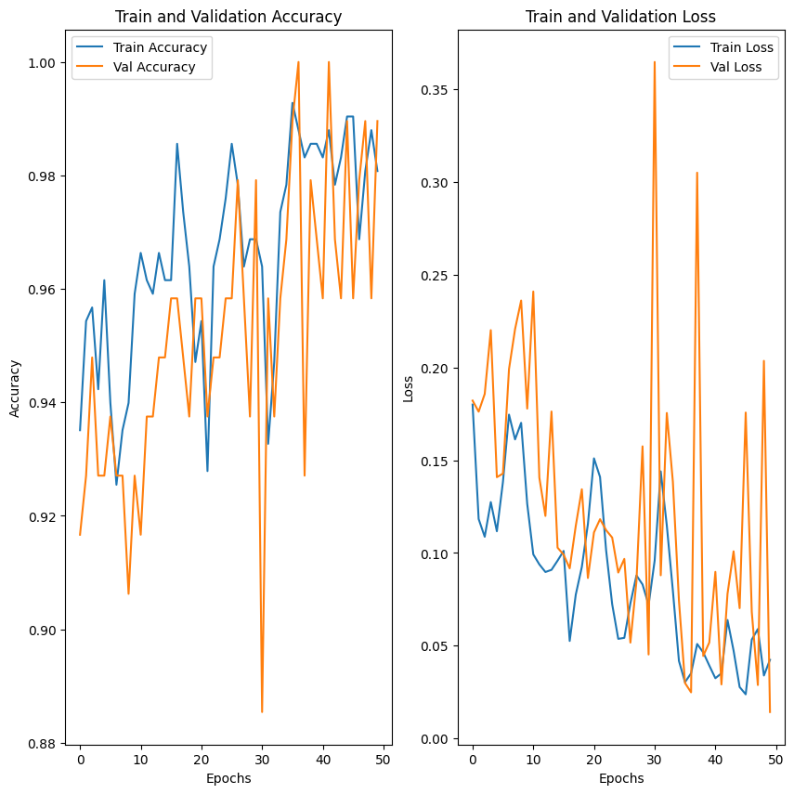

**Fig.** 4. Accuracy v/s Loss (50 Epochs) for Training and Validation.

In the third phase, we evaluated the model’s performance and outcomes by calculating the confusion matrix, accuracy, precision, recall, and f1-score as shown in the Classification Report (Table 2).

**Table 2**. Classification Report.

|  |  |  |  |  |
| --- | --- | --- | --- | --- |
| Classification Report | | | | |
| Class | **Accuracy** | **Precision** | **Recall** | **F1-Score** |
| 0 | 97.69% | 98.60% | 97.69% | 98.14% |
| 1 | 97.27% | 99.07% | 97.27% | 98.17% |
| 2 | 97.64% | 94.09% | 97.64% | 95.83% |
| 3 | 99.12% | 99.12% | 99.12% | 99.12% |
| 4 | 96.72% | 97.79% | 96.72% | 97.25% |
| 5 | 96.48% | 98.97% | 96.48% | 97.71% |
| 6 | 97.93% | 98.95% | 97.93% | 98.44% |
| 7 | 96.63% | 97.73% | 96.63% | 97.18% |
| 8 | 98.15% | 99.38% | 98.15% | 98.76% |
| 9 | 100.00% | 94.61% | 100.00% | 97.23% |

* 1. **Confusion Matrix**

Confusion matrix is a tabular representation used to evaluate model. It summarizes the predicted and actual labels of a model. Fig.5 represents the actual and predicted labels of 10 classes.

* 1. Classification Report

Accuracy: It is defined as the ratio of correctly predicted instances to the total instances (Fig. 6)

### **Precision :** Precision is defined as the ratio of true positive predictions to the total predicted positive instances(Fig. 7).

Recall: Recall, also known as sensitivity or true positive rate, is defined as the ratio of true positive predictions to the total actual positive instances (Fig. 8)

F1-score: The F1-score is the harmonic meaning of precision and recall (Fig. 9)

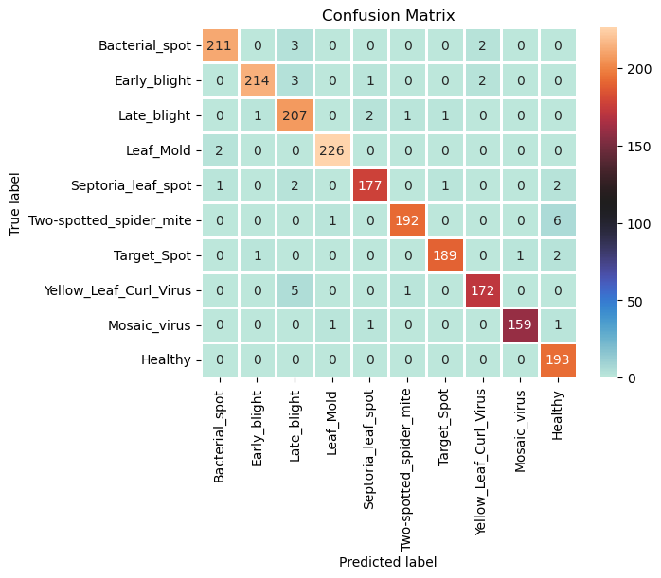

**Fig. 5.** Confusion Matrix

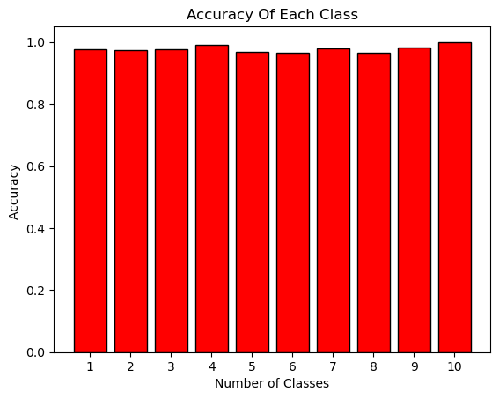

**Fig. 6**. Accuracy

**Fig. 7.** Precision

**Fig. 8.** Recall

**Fig. 9**. F1-score

Output & Result

Therefore, testing of the model was done by predicting the images in the test dataset. The accuracy of the test data resulted 97.78%.In Future There is a chance for the model to improve its performance with some methods such as hyper-parameter tuning, data validation, regularization, and semantic segmentation, especially when dealing with high complexity data by integration of ResNet50 and CNN for better classification of huge images dataset.

1. Conclusion

In conclusion, the proposed Convolutional Neural Network (CNN) approach for the early detection of diseases in tomatoes, which are susceptible to various pathogens worldwide, leading to significant losses in cultivation. Our model presented a fantastic outcome with the training accuracy of 98.6% and testing accuracy of 97.78% which is a clear indication that it is effective in detecting tomato leaf disease. As for the future, the directions for further research and development are numerous. First and foremost, the research may incorporate the expansion of the data set to include more varieties of the tomato leaf diseases which could increase the model’s capability to generalize the unseen data. Cooperation with agricultural specialists and stakeholders can enable the generation of user-friendly, cost-effective, and varieties of solutions targeted towards specific farmers. Through utilization of CNNs and image processing methods, we provide farmers with the equipment and knowledge they need to minimize the damage caused by diseases and hence, for food security and environment friendly agriculture.

1. Acknowledgement

We would like to extend our sincere gratitude to Madanapalle Institute of Technology and Science for the resources and support provided during the development of the Enhanced Deep Learning technique using CNN model to detect tomato leaf disease. Our profound thanks to Mrs. T.Swetha and Dr. S. Kusuma for their invaluable guidance, and our team members for their voluntary contributions. Warm acknowledgment from colleagues at the Department of Data science for their collaboration.

Funding: No funding received for the research.

Conflict of interest: The authors declare that there are no conflicts of interest.

References

1. S. Zhao, Y. Peng, J. Liu, and S. Wu, “Tomato leaf disease diagnosis based on improved convolution neural network by attention module, “Agriculture, vol. 11, no. 7, p. 651, 2021.
2. H. Y. Bayram, H. Bingol, and B. Alatas, “Hybrid deep model for automated detection of tomato leaf diseases,” Traitement du Signal, vol. 39, no. 5, p. 1781, 2022.
3. N. K. Trivedi, V. Gautam, A. Anand, H. M. Aljahdali, S. G. Villar, D. Anand, N. Goyal, and S. Kadry, “Early detection and classification of tomato leaf disease using high-performance deep neural network,” Sensors, vol. 21, no. 23, p. 7987, 2021.
4. P. Sreelatha, M. S. Udayakumar, S. Karthick, S. C. Ch, K. C. S.Kavya, and M. Madiajagan, “Managing the tomato leaf disease detection accuracy using computer vision based deep neural network,” Journal of Contemporary Issues in Business and Government, vol. 27, no. 1, 2021.
5. K. Zhang, Q. Wu, A. Liu, X. Meng, et al., “Can deep learning identify tomato leaf disease?,” Advances in multimedia, vol. 2018, 2018.
6. Y. Wu, L. Xu, and E. D. Goodman, “Tomato leaf disease identification and detection based on deep convolutional neural network.,” Intelligent Automation & Soft Computing, vol. 28, no. 2, 2021.
7. U. Mokhtar, M. A. Ali, A. E. Hassenian, and H. Hefny, “Tomato leaves diseases detection approach based on support vector machines,” in 2015 11th International computer engineering conference (ICENCO), pp. 246–250, IEEE, 2015.
8. F. P. Rani, S. Kumar, A. L. Fred, C. Dyson, V. Suresh, and P. Jeba, “K-means clustering and svm for plant leaf disease detection and classification,” in 2019 International Conference on Recent Advances in Energy-efficient Computing and Communication (ICRAECC), pp. 1– 4, IEEE, 2019.
9. N. Nahar, M. H. Imam, R. Bhowmik, M. A. Rahman, and I. Haque, “Tomato leaf disease detection using deep learning ensemble approach, Volume 14, Issue 12, December-2023
10. E. Cengil and A. C ̧ ınar, “Hybrid convolutional neural network based classification of bacterial, viral, and fungal diseases on tomato leaf images,” Concurrency and Computation: Practice and Experience, vol. 34, no. 4, p. e6617, 2022.
11. A. Fuentes, S. Yoon, and D. S. Park, “Deep learning-based techniques for plant diseases recognition in real-field scenarios,” in Advanced Concepts for Intelligent Vision Systems: 20th International Conference, ACIVS 2020, Auckland, New Zealand, February 10–14, 2020, Proceedings 20, pp. 3–14, Springer, 2020.
12. M. Loey, A. ElSawy, and M. Afify, “Deep learning in plant diseases detection for agricul---tural crops: a survey,” International Journal of Service Science, Management, Engineering, and Technology (IJSSMET), vol. 11, no. 2, pp. 41–58, 2020.
13. J. Ma, K. Du, F. Zheng, L. Zhang, and Z. Sun, “A segmentation method for processing greenhouse vegetable foliar disease symptom images,” Information Processing in Agriculture, vol. 6, no. 2, pp. 216–223, 2019.
14. T. A. Salih et al., “Deep learning convolution neural network to detect and classify tomato plant leaf diseases,” Open Access Library Journal, vol. 7, no. 05, p. 1, 2020.
15. A. Mortazi and U. Bagci, “Automatically designing cnn architectures for medical image segmentation,” in Machine Learning in Medical Imaging: 9th International Workshop, MLMI 2018, Held in Conjunction with MICCAI 2018, Granada, Spain, September 16, 2018, Proceedings 9, pp. 98–106, Springer, 2018.
16. M. Kaushik, P. Prakash, R. Ajay, S. Veni, et al., “Tomato leaf disease detection using convolutional neural network with data augmentation,” in 2020 5th International Conference on Communication and Electronics Systems (ICCES), pp. 1125–1132, IEEE, 2020.
17. Y. Li, Z. Luo, F. Wang, and Y. Wang, “Hyperspectral leaf image-based cucumber disease recognition using the extended collaborative representation model,” Sensors, vol. 20, no. 14, p. 4045, 2020.
18. K. P. Ferentinos, “Deep learning models for plant disease detection and diagnosis,” Computers and electronics in agriculture, vol. 145, pp. 311–318, 2018.
19. P. Sharma, Y. P. S. Berwal, and W. Ghai, “Performance analysis of deep learning cnn mod--els for disease detection in plants using image segmentation,” Information Processing in Agriculture, vol. 7, no. 4, pp. 566–574, 2020.
20. M. E. Chowdhury, T. Rahman, A. Khandakar, M. A. Ayari, A. U. Khan, M. S. Khan, N. Al-Emadi, M. B. I. Reaz, M. T. Islam, and S. H. M. Ali, “Automatic and reliable leaf diseasedetection using deep learning techniques,” Agri Engineering, vol. 3, no. 2, pp. 294–312, 2021.
21. A. Guerrero-Iba ̃nez and A. Reyes-Mu ̃noz, “Monitoring tomato leaf disease through convolutional neural networks,” Electronics, vol. 12, no. 1, p. 229, 2023.
22. M. S. Al-gaashani, F. Shang, M. S. Muthanna, M. Khayyat, and A. A. Abd El-Latif, “Tomato leaf disease classification by exploiting transfer learning and feature concatenation,” IET Image Processing, vol. 16, no. 3, pp. 913–925, 2022.
23. P. Tm, A. Pranathi, K. SaiAshritha, N. B. Chittaragi, and S. G. Koolagudi, “Tomato leaf disease detection using convolutional neural networks,” in 2018 eleventh international conference on contemporary computing (IC3), pp. 1–5, IEEE, 2018.
24. N. Khasawneh, E. Faouri, and M. Fraiwan, “Automatic detection of tomato diseases using deep transfer learning,” Applied Sciences, vol. 12, no. 17, p. 8467, 2022.
25. C. Mattihalli, E. Gedefaye, F. Endalamaw, and A. Necho, “Real time automation of agriculture land, by automatically detecting plant leaf diseases and auto medicine,” in 2018 32nd International Conference on Advanced Information Networking and Applications Workshops (WAINA), pp. 325–330, IEEE, 2018.